**Data Reduction Procedure**

1. Plot Pressure Altitude vs. Session time for the entire flight.

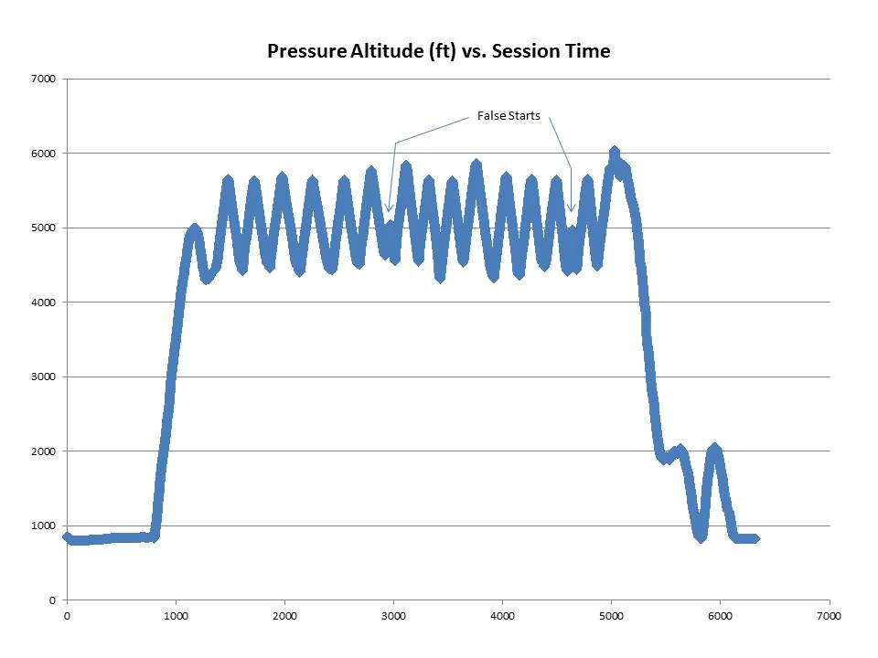

Find individual climb with a band of 400 feet centered about the altitude of interest 5000 ft. And plot the climb, for example: (other plots could be found in the attachment “Data Collected for Analysis.xlsx”)

1. Average the indicated airspeed over each climb run and convert KIAS to KCAS using the calibration in attachment “Airspeed Calibration.docx”. And yield the ratio of climb for the run. The data of Ratio of Climb and KCAS for all the 15 runs is listed in below table:

|  |  |  |
| --- | --- | --- |
| **Climb NO.** | **KCAS** | **Ratio of Climb** |
| 1 | 59.8748146 | 698.703 |
| 2 | 59.80634424 | 660.3 |
| 3 | 50.06318344 | 641.328 |
| 4 | 50.21272916 | 661.455 |
| 5 | 55.7807106 | 651.042 |
| 6 | 55.54383744 | 704.499 |
| 7 | 66.12074336 | 721.872 |
| 8 | 65.53657724 | 677.142 |
| 9 | 63.76098652 | 729.537 |
| 10 | 65.29788896 | 710.565 |
| 11 | 70.6929298 | 769.509 |
| 12 | 69.86019308 | 728.312 |
| 13 | 75.16951992 | 746.985 |
| 14 | 74.96541976 | 720.078 |
| 15 | 75.48978776 | 664.476 |

1. Add a data point for zero rate of climb at the maximum speed from the blue line on the chart below to above data table for plotting.

For 5000 ft, the KTAS is 119.3, convert KTAS to KEAS by multiplying with square root of air density ratio (0.9283) at 5000 ft pressure altitude.

$$V_{e}= \sqrt{σ}V=0.9283*119.3=110.74619$$

At low speed and low altitude, the KCAS is equal to the KEAS.

1. Plot the rate of climb as a function of KCAS and Use second order trend line to fit the curve.

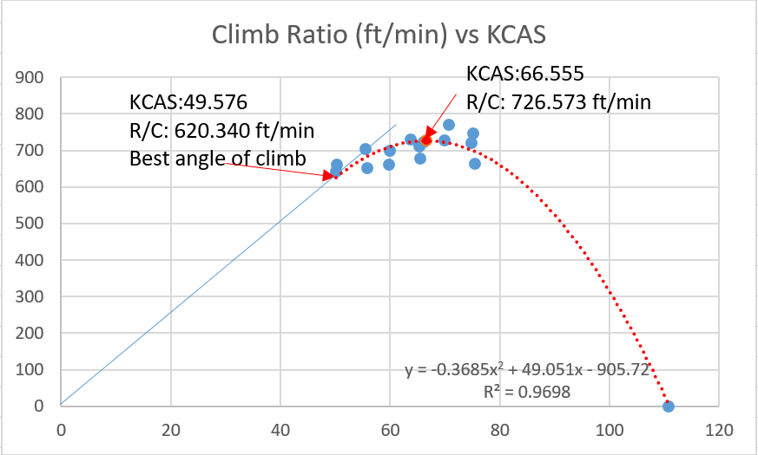

1. Calculate the best rate of climb and best angle of climb

* local maximum of rate of climb curve is at speed of KCAS 66.555, and the maximum climb ratio is 726.573 ft/min.
$$f\left(x\right)= -0.3685x^{2}+49.051x-905.72$$

$$f^{'}\left(x\right)=49.051-2*0.3685x$$

$$f^{'}\left(x\right)=0=>x=66.555$$

* Best angle of climb is at speed of KCAS 49.576 and the climb ratio of 620.340 ft/min.

$$ax = -0.3685x^{2}+49.051x-905.72$$

$$a=f\left(x\right)= -0.3685x+49.051-\frac{905.72}{x}$$

$$f^{'}\left(x\right)= -0.3685+905.72/x^{2}$$

$$f^{'}\left(x\right)=0=>x=49.576$$